**Sprint Plan 3 - NutriHall - CSE 115-A – Intro to Software Engineering - 11/05/24**

For sprint 3, we aim to have a working UI that displays the meals from each dining hall. Furthermore, we aim to implement functionality to store user preferences, restrictions, and past meals.

**Task listing, organized by user story:**

User Story 4:

As a student who pays attention to their diet, I want to be able to search through the meals available and add them to the list of things eaten so that I can calculate totals for the day.

Subtasks:

Task 1: Create a search bar on the front end to search meals by name or category. (3 hours)

Task 2: Build a back-end API to perform searches based on user input. (3 hours)

Task 3: Implement the functionality for users to add meals to a daily log. (3 hours)

Task 4: Update the database schema to store daily meal logs for each user. (3 hours)

Task 5: Create an API endpoint to calculate and return total nutrition values for the day. (3 hours)

Task 6: Integrate the totals into the front-end view for the daily log. (3 hours)

Task 7: Test the search functionality and meal logging system. (2 hours)

Task 8: Begin Jest testing structure, set up unit tests, Integration tests, functional tests, and End-to-end tests for previous and current user stories(15 hours)

Task 9: Host our website in Vercel (3 hours)

Total: 39 hours

User Story 5:

As a student who pays attention to their diet, I want to be suggested meal plans that fit within my restrictions and adhere to my goals.

Subtasks:

Task 1: Design a front-end UI for meal plan suggestions. (3 hours)

Task 2: Develop a meal plan algorithm that adheres to user restrictions and nutrition goals. (4 hours)

Task 3: Create an API endpoint to generate and return meal plans. (3 hours)

Task 4: Integrate the meal plan suggestions into the front-end interface. (3 hours)

Task 5: Test meal plan generation and ensure it aligns with user restrictions and goals. (3 hours)

Total: 16 hours

∙ **Team roles:**

Aiden: Developer

Violet: Developer

Artem: Developer & Scrum Master

Amish: Developer

Kevin: Developer

∙ **Initial task assignment:**

Violet: Begin learning about Jest and creating unit tests and general testing for previous/current user stories. Continue integration of backend components with frontend(displaying nutrient information to the frontend. Host our website in vercel.

Kevin: Applying ES lint code standards. Integrate user meal preferences from the backend. Combine preference contexts in the Firebase database. Integrate Firebase nutritional data with the frontend. Work on selecting and fine-tuning a model for meal suggestions.

Amish: In the front end, split menu items into subsections for each, split the menu into break/lunch/dinner/etc. Add searching functionality in the front end. Assist with developing a scraper and cataloging.

Aiden: Implement tagging for each item for meal (Breakfast, Lunch, Dinner) and Dining hall location. Scrape nutrition facts for each item.

Artem: Create the word search functionality. Assist with the tagging of colleges, nutritional macro information,and calories, and meal time within the scrapers. Implement tagging to display on different pages (in history for goals and in the different colleges). Combine preference context with preference database.

∙ **Initial burnup chart:**

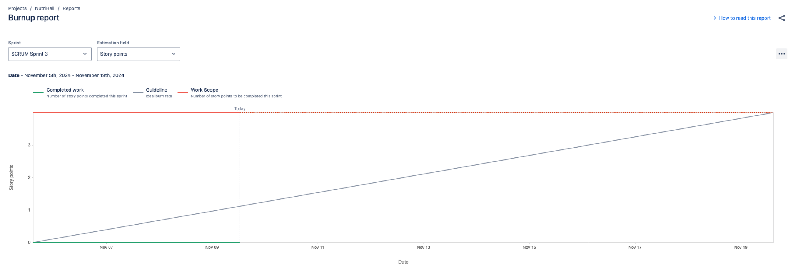

∙ **Initial scrum board:**

**Next page**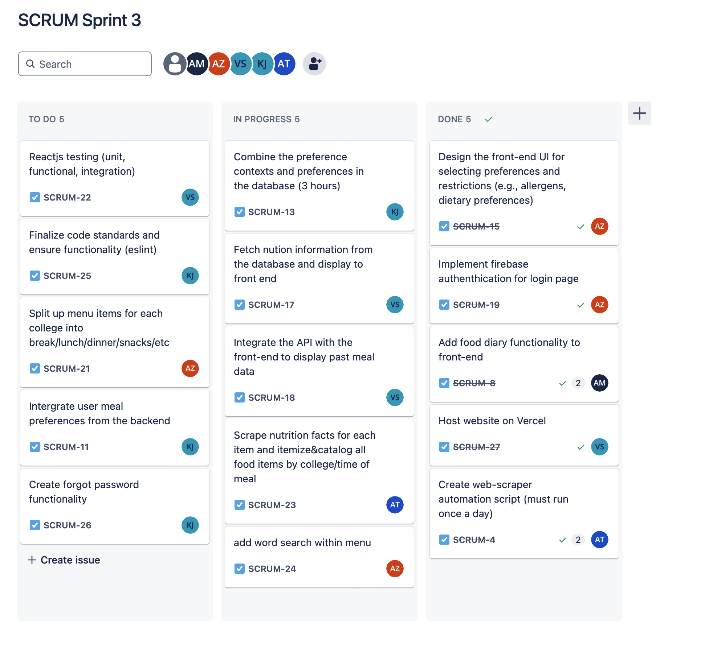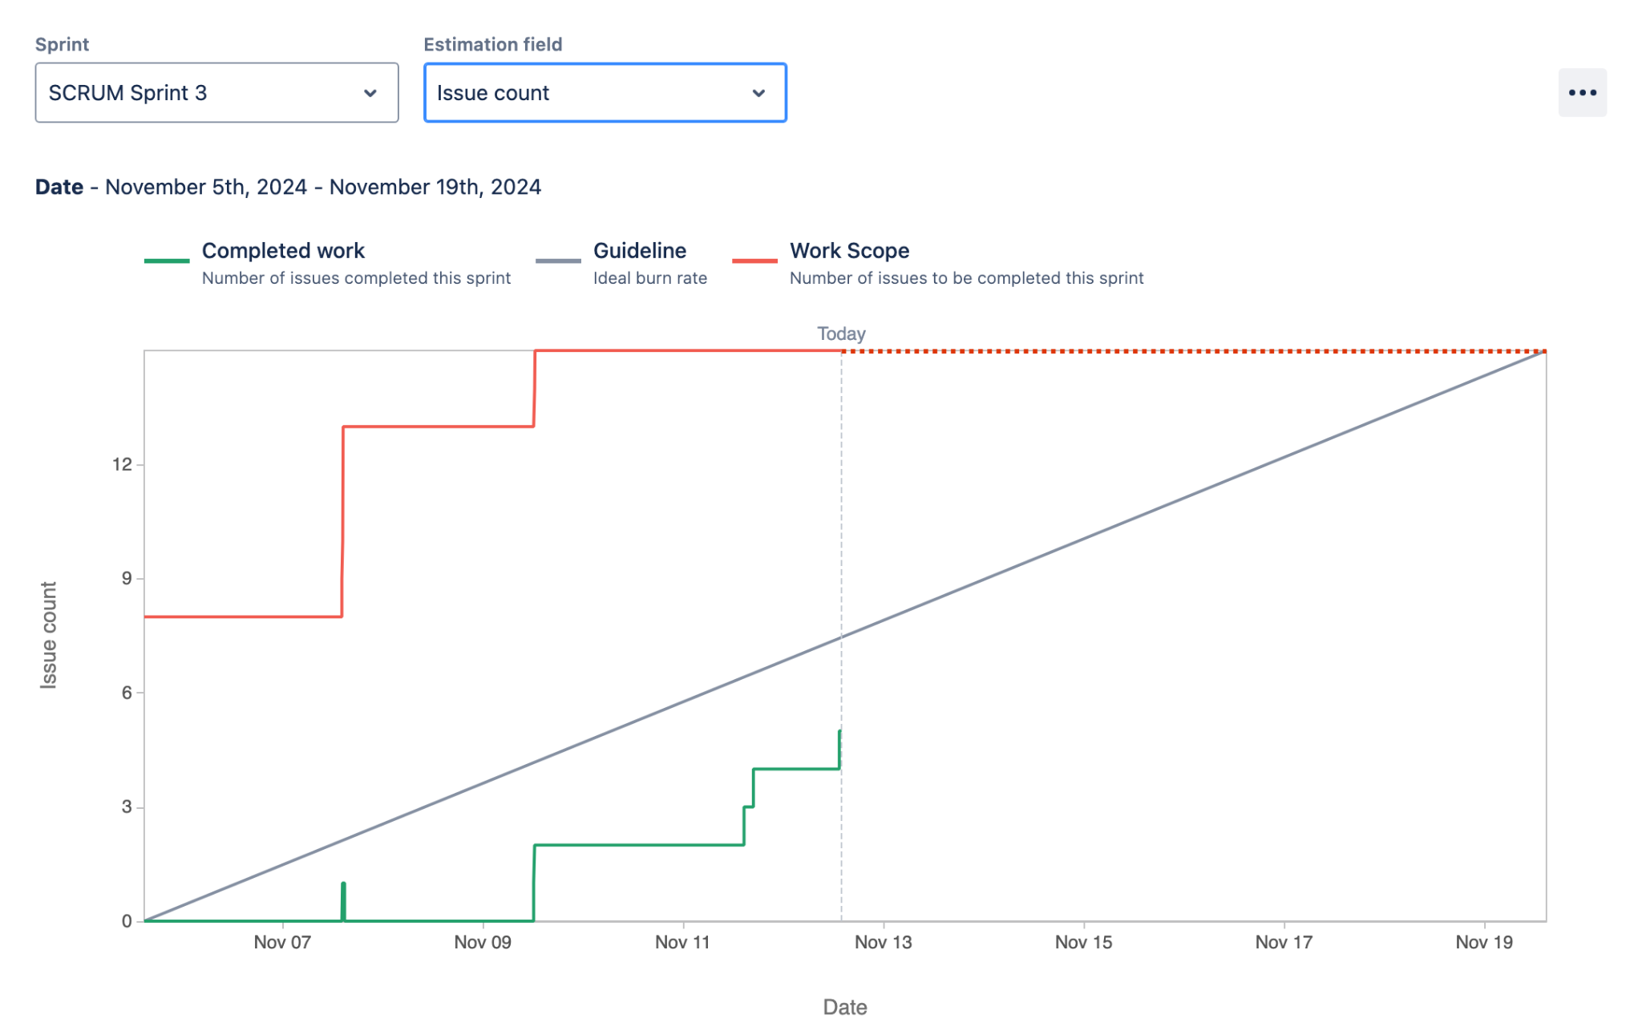

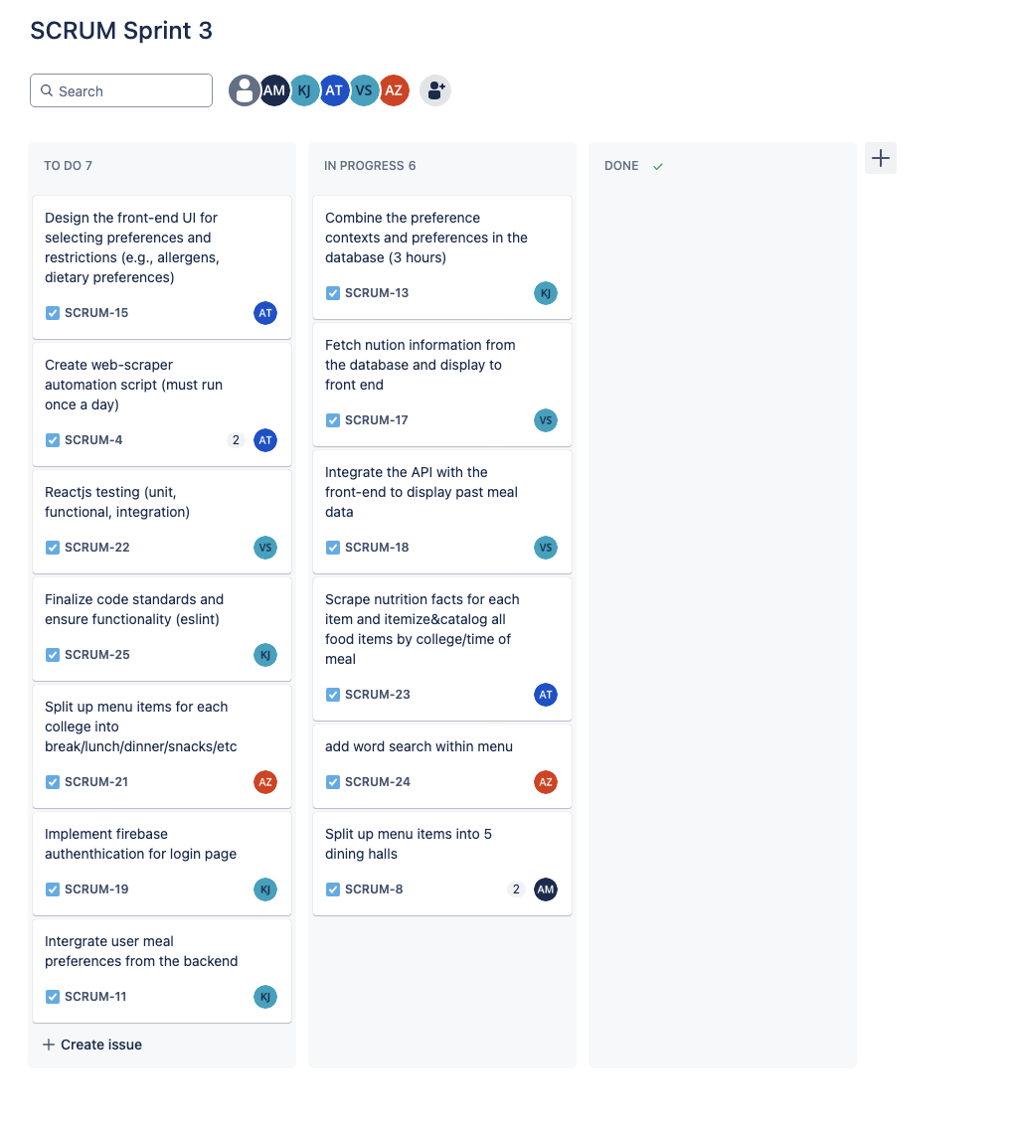

∙ **Scrum times:** Monday @ 2:30pm, Saturday @ 12pm, and Thursday 1:45pm